Multiple choice section

Question 1 [6.1]

Which of the following is the same as 65 cm?

A 650 mm B 6.5 km C 6.5 mm D 650 m

Question 2 [6.2]

The perimeter of a rectangle of length 70 m and width 6 cm is:

A 76 mm B 26 cm C 42 cm D 270 mm

Question 3 [6.6]

Assuming that each cube represents 1 cm3, the volume of the following object in cm3 is:

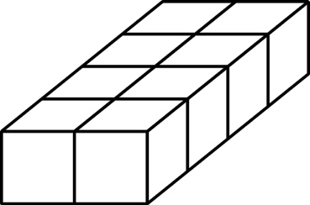

A 8 cm3 B 4 cm3 C 10 cm3 D 12 cm3

Question 4 [6.3]

A square of area 49 m2 has side length:

A 8 m B 7 m C 10 m D 12 m

Question 5 [6.1]

Which metric unit would be most appropriate for measuring the distance from  
Perth to Melbourne?

A metres B kilometres C centimetres D millimetres

Question 6 [6.1]

Which set of lengths are in ascending order?

A 7.7 m, 700 cm, 7 km, 70 m

B 70 m, 700 cm, 7.7 m, 7 km

C 700 cm, 7.7 m, 70 m, 7 km

D 7 km, 7.7 m, 700 cm, 70 m

Question 7 [6.3]

Which metric unit would be most suitable for measuring the area of a playing card?

A m2 B litres2 C mm2 D km2

Question 8 [6.3]

Assume the shape has been drawn on centimetre grid paper. Estimate its area.

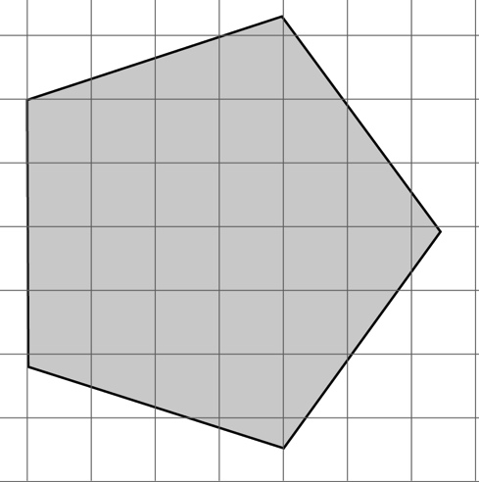

A 22 m2 B 2 cm2 C 3 mm2 D 30 cm2

Question 9 [6.4]

A parallelogram with a base of 11 cm, and a height of 5 cm has an area of:

A 55 cm2 B 16 cm2 C 5.5 cm2 D 16 m2

Multiple-choice total marks: ____ / 9

Short answer section

Question 10 3 marks [6.1, 6.4, 6.6]

Use words from the list below to complete the following sentences.

base multiply divide height length breadth

(a) To convert from a larger unit of measurement to a smaller unit, you __________________.

(b) The area of a parallelogram is calculated by multiplying the base by the perpendicular _____________.

(c) The volume of a rectangular prism is the product of its ____________, width and height.

Question 11 3 marks [6.1]

Complete the following conversions.

(a) 12 km = __________ m (b) 764 mm = _________ cm (c) 341 mm = __________ m

Question 12 2 marks [6.1]

The Richmond bridge is 41 m long and the Ted Smout bridge is 2740 m long. Convert these dimensions to kilometres, rounded to 2 decimal places.

Question 13 2 marks [6.1]

Max is knitting a scarf. If, at the end of Monday the scarf is 200 mm long and he can knit 15 cm in a day, how long is the scarf at the end of Saturday (in centimetres)?

Question 14 4 marks [6.2]

Draw a diagram and then find the perimeter of:

(a) a rectangle with a length of 22 cm and a width of 84 mm

(b) a square with side lengths of 520 mm.

Question 15 2 marks [6.2]

Find the perimeter of the following shape.

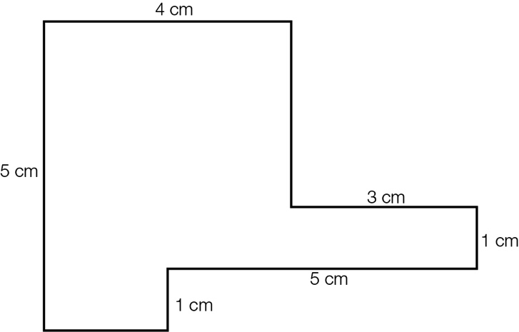

Question 16 3 marks [6.3]

Rahul has a rectangular backyard. In the middle of his yard is a pool measuring 12 m by 2 m, which is surrounded by a 1 m wide path and then a garden 2 m wide around the path. What is the total area of Rahul’s backyard?

Question 17 4 marks [6.3]

Find the area of the following.

(a) A square with side lengths of 1.2 cm.

(b) A rectangle with a length of 5.2 cm and a width of 6 cm.

Question 18 3 marks [6.3]

A window has a height of 1.5 m and is 900 mm wide. A curtain is to be made for the window. If the material for the curtain needs to be three times the width of the window and have a length 30 cm longer than the window, how much material is required to make the curtain (in square metres)?

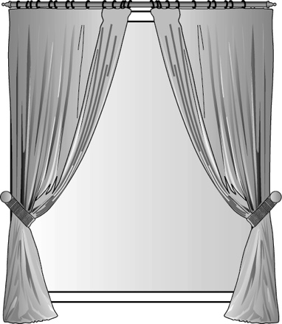

Question 19 2 marks [6.4]

Find the area of the parallelogram.

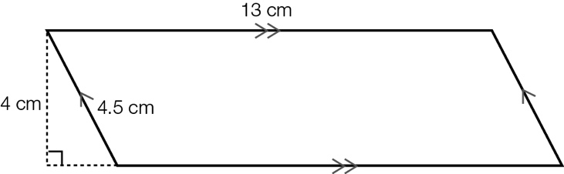

Question 20 3 marks [6.4]

A parallelogram has a base length of 8 cm and an area of 72 cm2. What is its height?

Question 21 2 marks [6.5]

Find the area of the triangle.

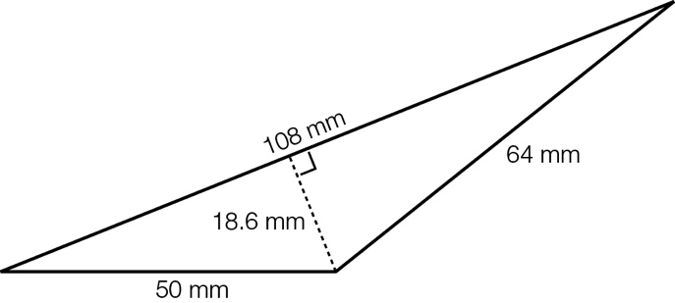

Question 22 3 marks [6.5]

Find the area of the following composite shape.

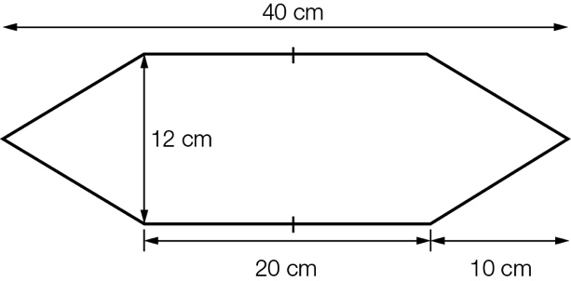

Question 23 3 marks [6.5]

Find the shaded area.

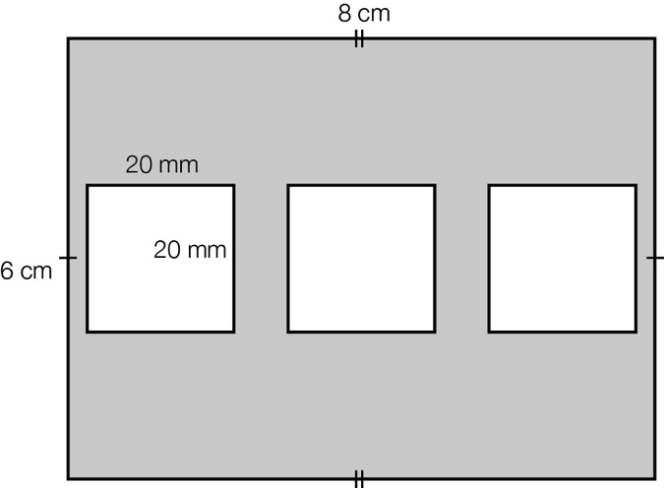

Question 24 2 marks [6.6]

Find the volume of the following. (Each small cube represents 1 cm3.)

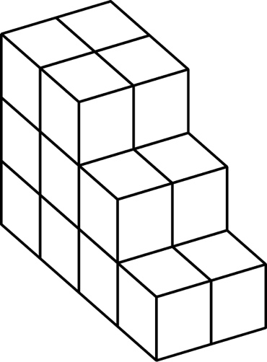

Question 25 2 marks [6.6]

Find the volume of the rectangular prism.

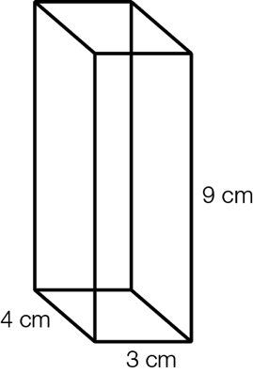

Question 26 3 marks [6.6]

A rectangular prism has a volume of 105 cm3. If its length is 7 cm and its width is 5 cm, what is its height?

Question 27 3 marks [6.5]

Kimberly is making a mosaic tray. If the tray measures 900 mm by 900 mm and each square tile has a side length of 2 cm, how many tiles are required to cover the tray?

Short answer total:_________/49

Extended answer section

Question 28 5 marks [6.6]

(a) A large carton contains 18 boxes of soap. If the dimensions of a box of soap are 150 mm by 60 mm by 110 mm, find the volume of the large carton.

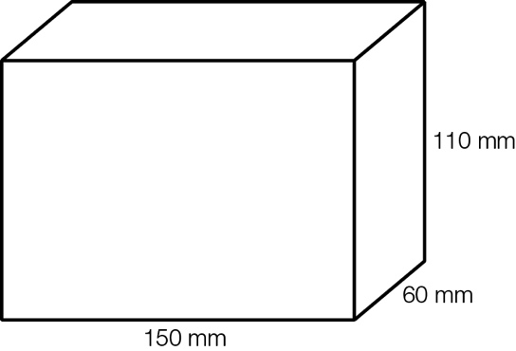

(b) If the soap boxes are stacked two high in the carton, what are the possible dimensions of the carton (in mm2)?

Question 29 2 marks [6.2, 6.3]

The following rectangle has an area of 18 cm2 and a perimeter of 18 cm. Find another rectangle that has the same numerical value for the both its area and its perimeter.

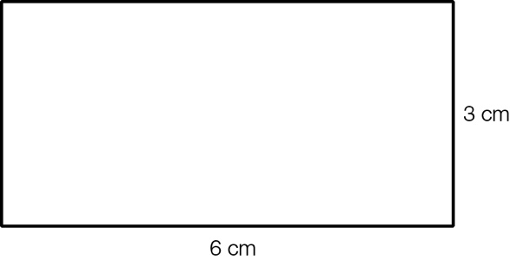

Question 30 4 marks [6.3]

Angus wants to cover a wall with some artwork. He wants to buy three canvases of the same size. The wall measures 2.4 m in height and 4 m wide. The canvases are to be placed with a 10 cm gap between each canvas and the ends of the wall.

(a) Which canvas from the list below will be the best fit? (Angus wants to use most of the wall)

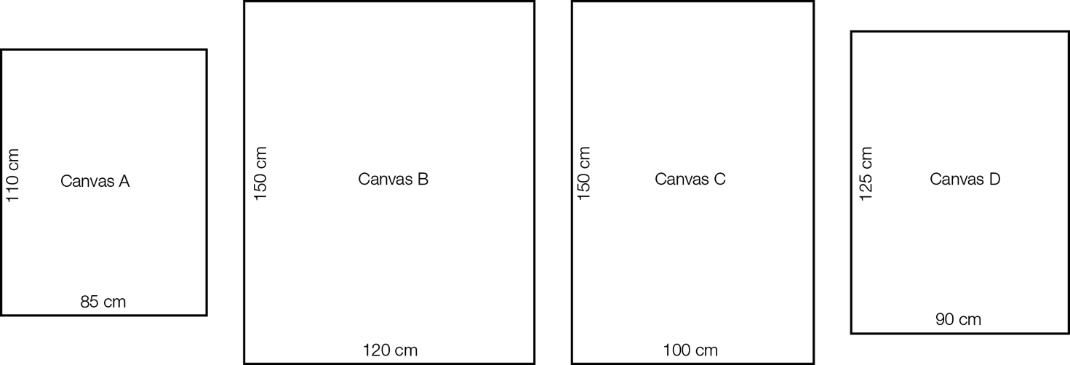

(b) What is the total area of the three canvases?

Extended answer total:_________/11

TOTAL test marks: _______ / 69